Department of Electrical and Computer Engineering

North South University



CSE 499A.7

Senior Design Project

**Title: Online Class & Examination Monitoring System**

Reported by

|  |  |  |
| --- | --- | --- |
| **Name** | **ID** | **Section** |
| Galib Faruk Gani | 1531012642 | 7 |
| Rubaida Ferdous | 1711126042 | 6 |
| Kazi Moshiur Rahaman | 1712832642 | 7 |
| Md Sharif Hossain | 1712336642 | 7 |

Faculty Advisor:

**Dr. Mohammad Ashrafuzzaman Khan**

Associate Professor Department of ECE

Spring 2021

**Letter Of Transmittal**

May, 2021

To

**Dr. Mohammad Ashrafuzzaman Khan**

Associate Professor,

Department of Electrical and Computer Engineering,

North South University, Dhaka.

**Subject:** Online Class & Examination Monitoring System.

Dear Sir,

With due respect, we would like to submit our report on “Online Class & Examination Monitoring System” as a part of our BSc program. The report talks about the video conferencing system and how we have worked on it to make it better not only for the students but also for the teachers too.

We are presenting this report to you and we are looking forward for your valuable judgment. It would be our pleasure if you find this report useful and we would be very grateful on you if you help us with our project with our thoughts and guidance.

Sincerely Yours,

**Md Sharif Hossain**

ID: 1712336642

Department of Electrical and Computer Engineering,

North South University, Dhaka

**Kazi Moshiur Rahaman**

ID: 1712832642

Department of Electrical and Computer Engineering,

North South University, Dhaka

**Rubaida Ferdous**

ID: 1711126042

Department of Electrical and Computer Engineering,

North South University, Dhaka

**Galib Faruk Gani**

ID: 1531012642

Department of Electrical and Computer Engineering,

North South University, Dhaka

**Declaration**

This is our truthful declaration that the **“**Online Class & Examination Monitoring System**”** we have prepared is not a copy of any other online video conferencing system previously made by any other team. We also express our honest confirmation in support of the fact that the said **“**Online Class & Examination Monitoring System**”** has neither been used before to fulfill any other course related purpose nor it will be submitted to any other team or authority in future.

**Acknowledgement**

First of all, we wish to express our gratitude to the Almighty Allah for everything that Allah has provided us with. We would also like to express our profound gratitude to our honourable course instructor, **Dr. Mohammad Ashrafuzzaman Khan,** for his constant and meticulous supervision, valuable suggestions, his patience and encouragement to complete the thesis work. We would also like to thank the ECE department of North South University for providing us with the opportunity to have an industrial level design experience as part of our curriculum for the undergraduate program. Finally, we would like to thank our families and everybody who supported us and provided with guidance for the completion of this project.

**Abstract**

In this pandemic situation, most educational institutions and many business organizations conduct their activities over online meeting platforms like Google Meet or Zoom. But these applications only provide a meeting platform. The host needs to monitor the members manually. In the online examinations, teachers need to monitor the students' activities one to one by themselves.

We are planning to build a platform that will provide a video conferencing service. This project's primary purpose is to identify the meeting members by face recognition, monitor their body gestures, and give a summary to the host. Also, it will provide more fair exam policies by object and sound detecting, gestures and motions monitoring and screen freezing during an examination.

**Table Of Contents**

Table of Contents

1. Introduction 8

1.1 Problem Analysis 8

1.2 Related Works 8

1.3 Motivation 8

1.4 Overview 8

2. Methodology 10

2.1 Features 10

2.2 Used Platforms 11

3. Result Analysis 12

3.1 Works done over the course 12

3.2 Future works 12

4. Conclusion 13

4.1 Team contribution 13

4.2 Discussion 13

# Introduction

## **Problem Analysis**

In this pandemic situation, most educational institutions and many business organizations conduct their activities over online meeting platforms like Google Meet or Zoom. But these applications only provide a meeting platform. The host needs to monitor the members manually. In the online examinations, teachers need to monitor the students' activities one to one by themselves.

## **Related Works**

In this pandemic situation, most educational institutions and many business organizations conduct their activities over online meeting platforms like Google Meet or Zoom. But these applications only provide a meeting platform. The host needs to monitor the members manually. In the online examinations, teachers need to monitor the students' activities one to one by themselves.

## **Motivation**

We have faced unfairness and complexities while attending online classes and examinations. Our honourable faculties face challenges too to monitor each student while conducting classes. From this experience we decided to design a platform which will give a better online class and examination conducting platform.

## **Overview**

This is the report of a project considering the use of video conferencing for taking online classes and examination. For the recent outbreak of covid in 2019 all educational institutes are facing problems as they are not being able to take physical classes due to the fear of infection which has somewhat pushed the educational institutes towards online classes, which has turned into a challenge. The use of online video conferencing system was not that wide spread in the educational system before, but the use of video conferencing system has incensed in huge numbers. The use has increased that is true but the problems stayed and through this project we are trying to overcome the problems we have pointed out the problems that a lecturer faces while taking a class or an exam.

There are a number of well-known systems or web applications like zoom, cisco WebEx, google meet and the list goes on, but none of them are equipped with the proper tools that are needed to be present in this modern-day pandemic situation. We are working on such a web application which will be able to not only host meeting like every other video conferencing system but will also reduce the work of the person who is hosting the class or exam, it will check if the person who is entering the meeting is the one intended to join the meeting or not by face detection which will make the video conferencing system not only smarter but safer too. Due to online classes teacher cannot concentrate on each and every student and we have thought of it too in every specific interval the system will check if the student is there or not if the student is actually concentrating in the meeting or not, further we are trying to detect if students are on the same tab or not which means the student cannot copy in exam and were are also working on object detection which will make things easier from the teachers side too as they will get an alert when our system detects something unusual.

# Methodology

## **Features**

* + 1. Anyone can sign up and log in to the platform using emails to create a meeting link.
    2. Hosts or admins can create meetings and invite members.
    3. Hosts can schedule meetings for specific times and can get reminders before the meetings.
    4. Members can join a pre-existing meeting created and shared by hosts.
    5. If someone tries to join a meeting that the host didn't invite, it will ask for the host's consent to accept that client.
    6. Besides email, each client will be verified by face recognition while joining a meeting.
    7. In a general meeting, clients' body gestures will be monitored, and a summary of the monitored data will be delivered to the host daily or weekly or monthly.
    8. There will be another option to conduct an online examination. During examinations object, noise and gestures detection system will let the host know about using various external things like mobiles, books, or outsiders.
    9. While conducting an examination, the screen freezing feature will give the facility to freeze the device screen after providing the question paper.

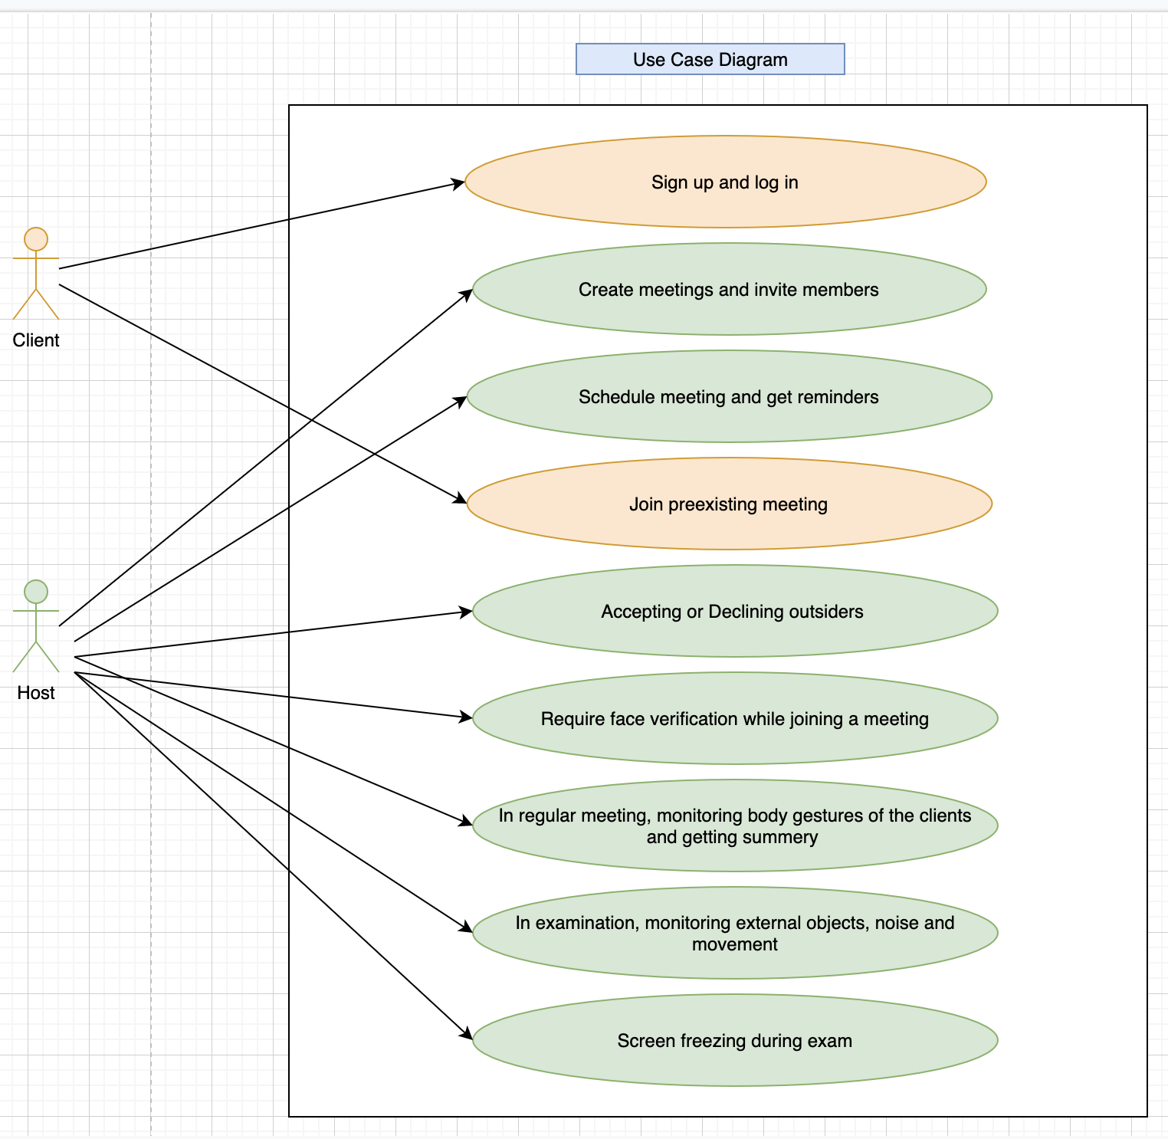

**Figure:** Use Case Diagram

## **Used Platforms**

We have mostly worked with JavaScript as it is a client scripting language which is widely used for creating web pages and web applications.

We have use Visual Studio Code as editor and we have worked on react framework for the making the video conferencing system. React is an open-source front-end JavaScript library for building user interfaces or UI components. It is maintained by Facebook and a community of individual developers and companies. React can be used as a base in the development of single-page or mobile applications.

For the face and object detection we will are taking help of Google cloud API

# Result Analysis

## **Works done over the course**

This is the basic frame of the video conference system that we have made. A host can create meeting in our system. The host would have to give their names and a name to the room to create a meeting room. After creating the room, the host can share the link of the room to other people. We are working on different ways to share the link to the members of the meeting.

There will be a security system before the users can enter the room. We will use email verification and face detection to check the identity which will not only help the teacher or the host but also make it more secure for the students too as no one else would be able to enter the meeting.

New members can join the meeting by the shared link and can chat while conducting the meeting.

## **Future works**

We are already done with then demo video conferencing system and we and we are currently trying to infuse the object detection and face detection tool with the video conference system.

We would add an activity alert system with the video system with the help of it the host would be able to see if the members are concentrating on the online class or are they surfing internet.

We are also planning to improve the way our system looks, we would work further on the frontend and backend too

We would be planning on more security features to further more increase the security of the system and we would add more ways of sharing the link to join the meeting.

# Conclusion

## **Team contribution**

This project needed more research time rather than hard coding. We needed to use open-source solution parts for our project. Teamwork helped to research from the huge source of internet and find a considerable solution set.

Work distribution: Galib Faruk Gani (GG), Rubaida Ferdous (RF), Md Sharif Hossain (SH), Kazi Moshiur Rahaman (KR)

|  |  |
| --- | --- |
| **Tasks** | **Responsibilities** |
| Problem Analysis | GG, RF, SH, KR |
| Project proposal | GG, RF, SH, KR |
| Solution Analysis | GG, RF, SH, KR |
| Functional Analysis and use case diagram | RF, SH, KR |
| Video conference analysis research | GG, RF, SH, KR |
| Video conference implementation | SH, KR |
| Face recognition analysis research | GG, RF, SH, KR |
| Face recognition implementation | GG, RF, SH, KR (Ongoing) |

## **Discussion**

The main motive of this project was to help the teachers with online classes and altogether form a better system which can be of better use in the current situation of the covid outbreak, as we are fairly new to this out break and online classes I believe this new system that we are working on and the extra features that we are putting in the system will not only help the host/user now in the situation but will also be of greater use after the pandemic.